School Community:
Students learn in an environment that is positive and engaging about Drawing. Missy always comes to the classroom with a lot of enthusiasm for upcoming drawing projects. This creates an engaging environment for the students to learn. She also promotes a friendly and welcoming classroom which creates a good culture amongst the students. Building community seems like an essential part of Ms. Wolf’s Art Classroom. There is daily video announcements to let students know what clubs are doing and tell them how they can be involved. Right now a program that the whole school is participating in is an energy saving initiative. If the school can come together to save the most energy out of all the schools in the district, they could win $5,000! The demographics of the school is all over the board as Fort Collins is an area of varying income. The student population as in in most of Colorado is Caucasian. The next largest ethnicity seems to be Hispanic. The main mission of the school is community. This has been shown on many instances because the students are consistently helping each other out.
Students and Classroom:
The students I will be teaching range from Freshman to Senior level. They all have a variety of interests, we have some soccer players, some students who are on the gymnastics team. They have varying developmental levels since they are different ages and different ability levels in art. One student seems to be on the spectrum of autism while others seem to be advanced in their studio art practices. We will be covering drawing techniques with a range of mediums throughout the semester.

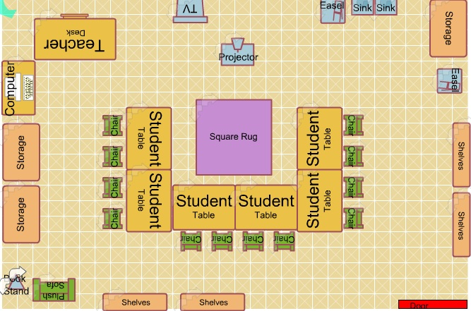
Section 2: Modifications, Adaptations, Accommodations
Students have come into the classroom with clear drawing experience. They ask me in depth questions about how to improve their works and what drawing techniques should be utilized. The knowledge on shading and stippling demonstrates to me that these students have more prior knowledge on the subject.
The way I will modify needs of all students is to explain things visually and verbally. This will satisfy the needs of all learners by teaching things in multiple methods. To further support students I will “work the room” while they work to lend further assistance.
One of my students, seems to be on the spectrum for Autism. He seems to have trouble associating with others and needs to be approached slowly. He will likely need extra assistance in the ideation phase of making arts. Last class we talked through some ideas together to help him get started on his drawing and to boost his social skills. I want to work on building a connection with this student to help him excel.
Another student seems like he could use help thinking of new art ideas as well. He likes to incorporate a lot of mushrooms into his work which seems to be a drug reference. I am still not completely sure how to handle this (since I am not entirely sure it is meant to be a drug reference) other than encouraging him to make other environments that are interesting and will pertain to his piece.

